Design Documentation

# Game details

## Game description

My game is an infinite climber, where three players must avoid objects or they lose a life. Players jump from bar to bar, and if they fall through the bottom of the screen they die. The last player alive wins.

## Toy + Puzzle + Goal

Toy - The toy in my game is the controllable sprite which can jump up bars and move left and right.

Puzzle - The puzzle in my game is to avoid touching objects and avoid falling off of the bottom of the screen

Goal - The goal in my game is to stay alive the longest out of the other players.

## Storyboard

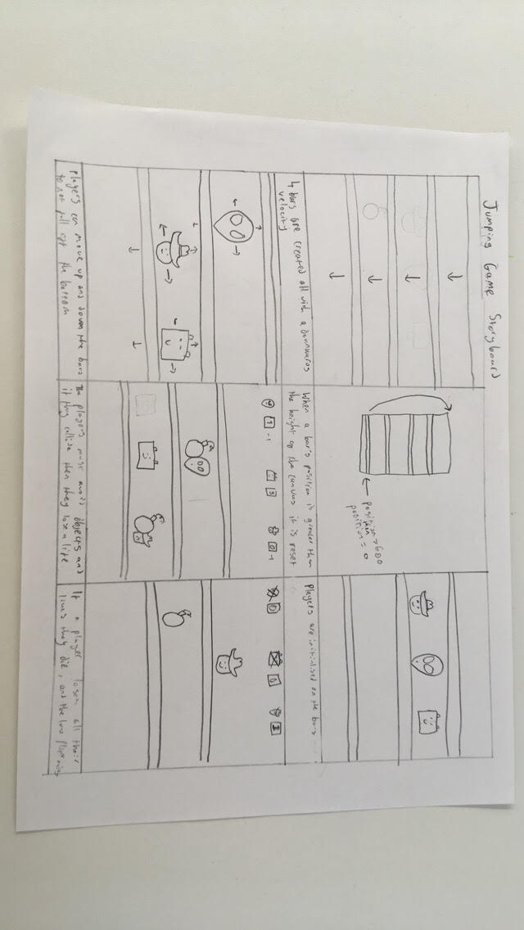

## Paper design

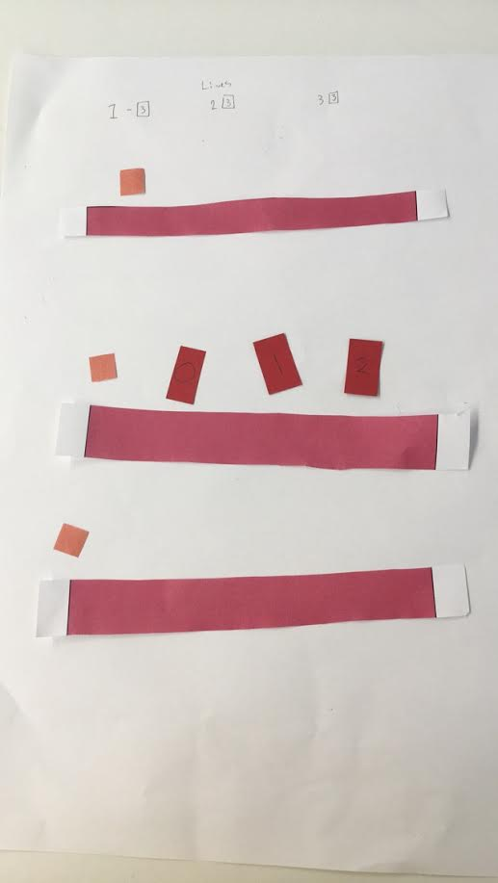

This image shows the players in their starting positions represented by the red numbered squares, the bars represented by the pink, and the objects to avoid represented by the orange squares. The scores for each player are also represented at the top.

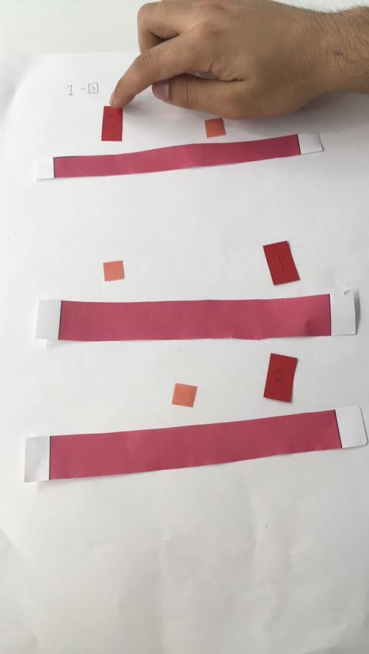

Here the user is controlling the player and the bars decreasing in height.

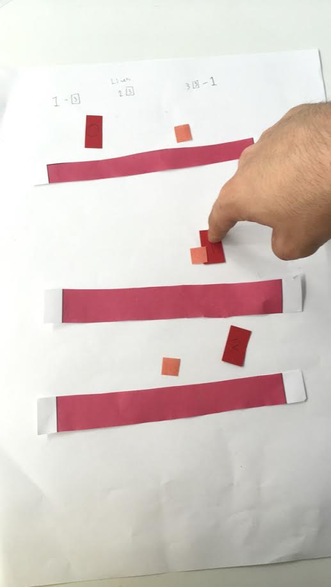

This is a player attempting to dodge an object but is hit, and thus loses a life.

# Feedback and optimisation

## Design feedback

All feedback is recorded in the surveys which I have created.

One user wrote: “Floppy Disk Emoji as it fits with the colour scheme well! :)”

Another said: “lives and making it more competitive between players”

## Design optimisation

I have made the objects of the game floppy disks as per the feedback I received. I did this as I believe that this object is quirky and makes the game interesting. I have also decided to change the name of my game to Floppy Jump as I feel that this name is appropriate and likeable.

I have also decided to incorporate the lives feedback so that players have three lives and they die when they lose all their lives through colliding with objects.

## Evaluation of design optimisation

I have taken into account the feedback quoted in my design feedback section as I feel this is really useful feedback which I believe should go into the final version of the game.

I discarded feedback such as the preferred game names as I have found a better name than the ones I listed. I have also discarded feedback such as the suggestion of bombs as the object which the user must avoid, as I felt this was generic and less interesting than the floppy disks.